VENANGO TECHNOLOGY CENTER
JOINT COMMITTEE
1 Vo-Tech Drive
Oil City, Pennsylvania 16301

MINUTES

January 2, 2023

The regular meeting of the Venango Technology Center Joint Committee was held this evening in the Conference Room of the Venango Technology Center, 1 Vo-Tech Drive, Oil City, PA 16301. Mr. Marterella called the meeting to order at seven o’clock (7:00) p.m.

Mr. Marterella asked the members to pause for a moment of silence.

Mr. Marterella asked the members to stand for the pledge of allegiance.

Roll Call: Present: Troy Johnston, Cheryl Ferry (zoom), Stephen Kelley, Lynn Cressman
(zoom), Jeff Thomas (zoom), Shari Neely, Dr. Melanie Anderson,
Mark Marterella

Absent: Ben Carbaugh, Andy Boland

Also Present: Mr. Mario Fontanazza, Mr. Bill Vonada

Mr. Marterella stated the Joint Committee members had received copies of the Minutes of the December 8, 2022 meeting in the mail. He asked if there were any additions, corrections or deletions.

Mrs. Neely, seconded by Mr. Kelley, moved to approve the Minutes of the December 8, 2022 meeting as submitted.

Roll Call: Ayes: Troy Johnston, Cheryl Ferry, Stephen Kelley, Lynn Cressman,
Jeff Thomas, Shari Neely, Dr. Melanie Anderson, Mark Marterella

Nayes: None, motion carried.

The Treasurer and Secretary’s Report as of 1/2/23 was submitted for information.

Mr. Kelley, seconded by Mrs. Neely, moved to accept the Treasurer and Secretary’s Report as of 1/2/23 as submitted.

The motion was unanimously approved.

A list of bills from in the amount of $477,932.38 was presented for approval.

Mrs. Neely, seconded by Mr. Johnston, moved to approve the list of bills as presented.

Roll Call: Ayes: Troy Johnston, Cheryl Ferry, Stephen Kelley, Lynn Cressman,
Jeff Thomas, Shari Neely, Dr. Melanie Anderson, Mark Marterella

Nayes: None, motion carried.

Under Communications, Mr. Fontanazza discussed the Professional Advisory Committee. He also discussed the Calendar of Events for the month of December and the Monthly Enrollment Report as of 1/2/23 were submitted.

Mr. Marterella requested nominations for Board Treasurer.

Mr. Kelley, seconded by Mr. Johnston, moved to elect Shari Neely as Treasurer of the board.

Roll Call: Ayes: Troy Johnston, Cheryl Ferry, Stephen Kelley, Lynn Cressman,
Jeff Thomas, Shari Neely, Dr. Melanie Anderson, Mark Marterella

Mr. Marterella requested approval of the action items as presented. Item 8. a) ii.- xi. in one motion.

Mrs. Neely, seconded by Mr. Johnston, moved to approve action items 8. a) ii.- xi. as follows:

- Approve additions to Occupational Advisory Committees.
- Approve Adult Evening School Schedule for Spring 2023.
- Approve hiring the successful candidate for the part-time Practical Nursing position at step 1 of the collective bargaining agreement prorated for the number of days worked.
- Approve the Guidance Services plan.
- Approve substitute instructor list.
- Approve Practical Nursing substitute list.
- Approve the K-12 Comprehensive Guidance Plan.
- Approve equipment list for disposal.
- Approve Advertising for the Electronics instructor.
- Approve 2023-2024 Budget.

Roll Call: Ayes: Troy Johnston, Cheryl Ferry, Stephen Kelley, Lynn Cressman,
Jeff Thomas, Shari Neely, Dr. Melanie Anderson, Mark Marterella

Nayes: None, motion carried.

Mr. Fontanazza reviewed his Issues/Activities for December 2022.

Mr. Marterella asked if there was any old business.

None was noted.

Mr. Marterella asked if there was any new business.

None was noted.

Mr. Adams reminded the members that the annual Authority meeting would take place immediately after the regular meeting of the Joint Committee on February 6, 2023.

Upon motion by Mr. Johnston, seconded by Mrs. Neely, the meeting adjourned at ten minutes past seven (7:10) p.m.

Recorded by
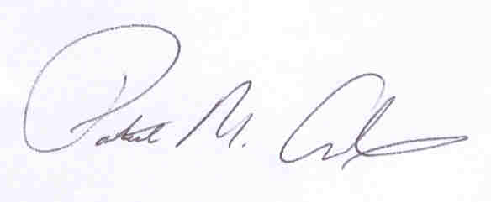
Patrick M. Adams
Secretary, Joint Committee

